Help WF – Hide reprove button from My Inbox App

Enter SPRO transaction
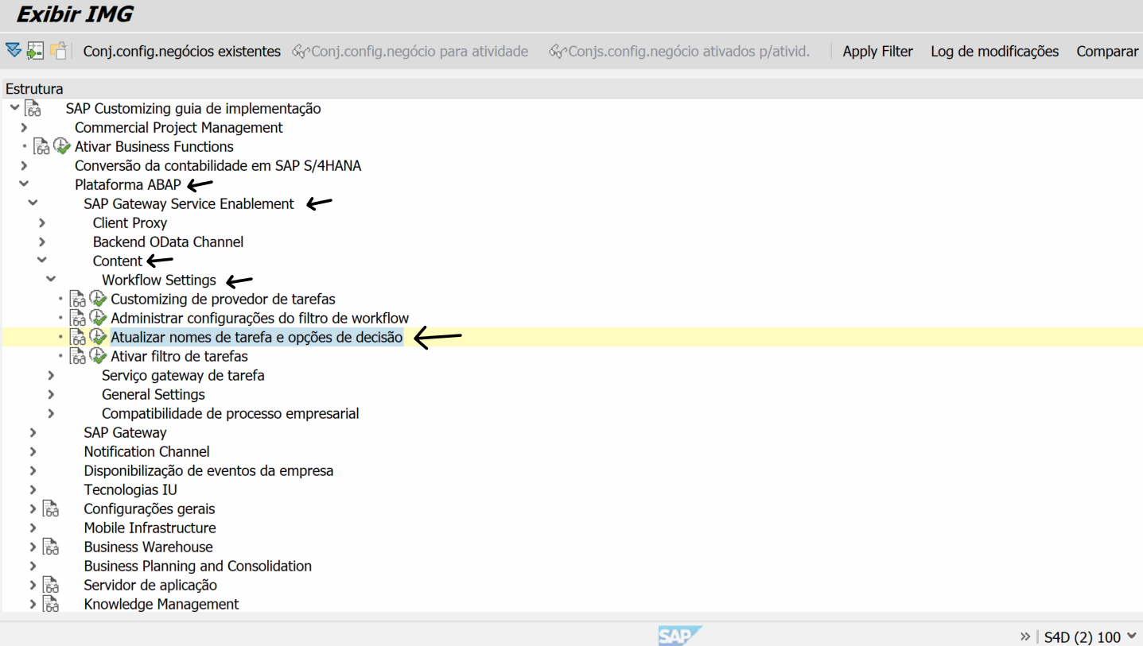
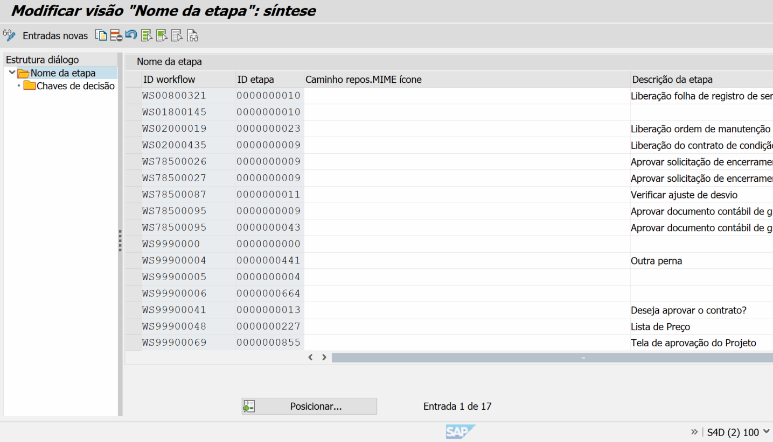

Add your workflow and step
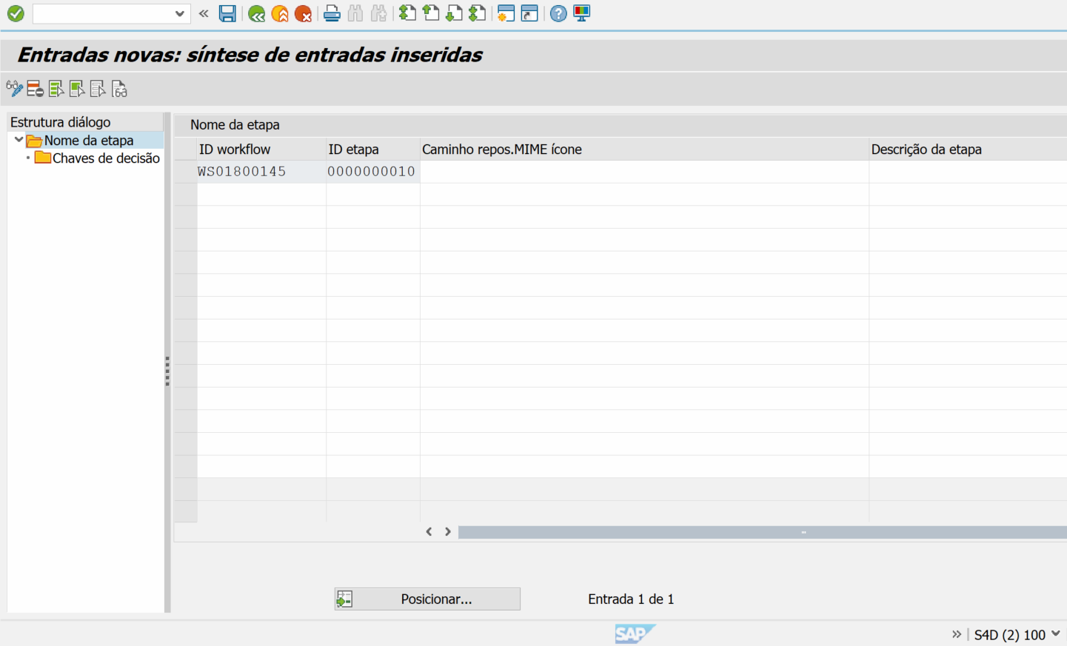

Add buttons you want (and do not add the reprove button).
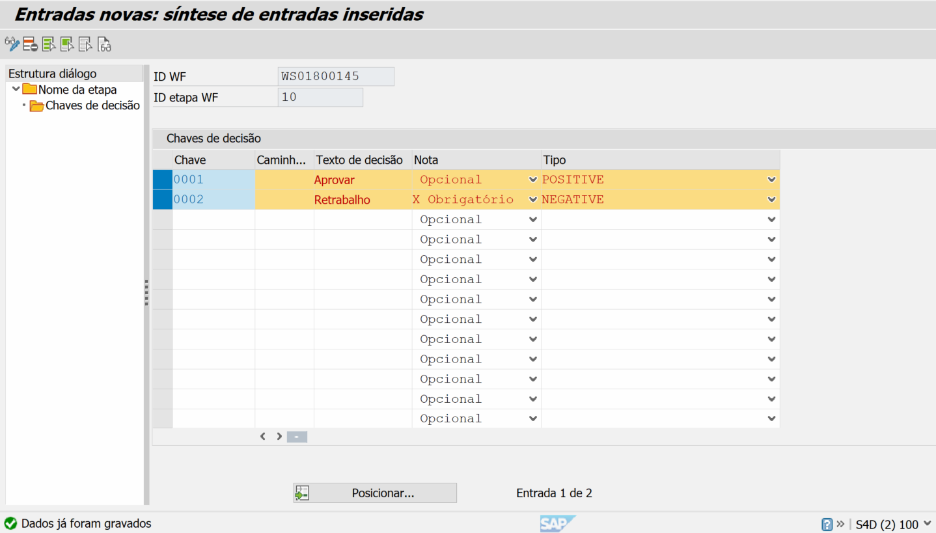

Make SCC1 to copy your Customizing request to test environment
See the result in My inbox
The Reprove button is hidden.
